**Project Documentation**

Data Insights Pipeline: SuperStore Analysis

**Table of Contents**

1. Introduction

2. Project Overview

3. Business Objectives

4. Data Sources

5. ETL Process

6. Storage Layers

7. Data Visualization

8. Machine Learning Models

9. Insights and Recommendations

10. Conclusion

**1. Introduction**

In today's data-driven world, businesses are increasingly recognizing the value of leveraging data to gain insights, make informed decisions, and drive growth. This project revolves around the creation of a robust data transformation and analysis pipeline for a fictional company, leveraging data from its Microsoft SQL Server database named "SuperStore." By establishing a comprehensive pipeline that encompasses data extraction, transformation, storage, visualization, and utilization of machine learning models, the project aims to empower the company to unlock the full potential of its data assets.

**2. Project Overview**

The project at hand represents a holistic approach to data management and analysis. It involves the development of a structured pipeline that facilitates the extraction of data from the SuperStore database, transformation of the extracted data to derive actionable insights, storage of processed data in different layers, visualization of insights using Tableau, and utilization of machine learning models for predictive analytics. By following this systematic approach, the project aims to enable the company to make data-driven decisions, optimize operations, and drive business growth.

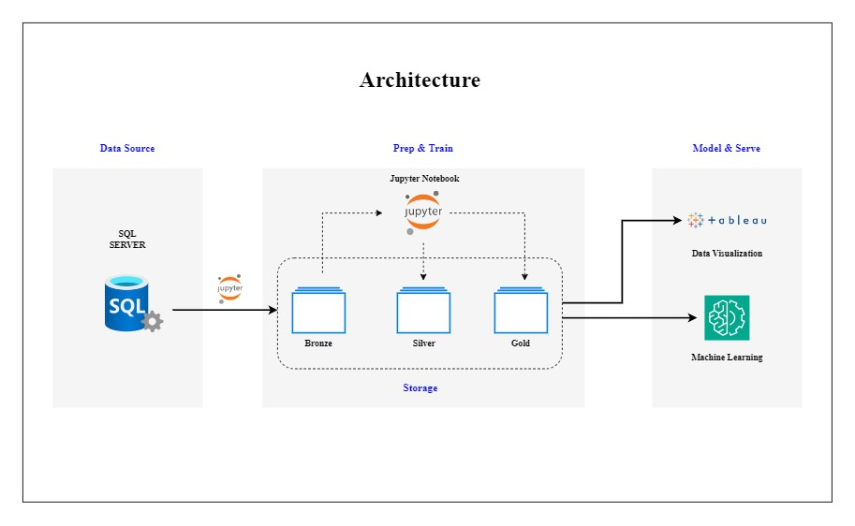

**3. Business Objectives**

At the core of the project lie several key business objectives:

1. Insight Generation: To gain insights into customer behaviour, product performance, and sales trends.
2. Optimization: To identify opportunities for business optimization and growth.
3. Strategy Development: To develop targeted strategies for customer retention, revenue enhancement, and market expansion.
4. Predictive Analytics: To implement predictive analytics to forecast future trends and outcomes.

By achieving these objectives, the project seeks to empower the company to stay competitive, adapt to market dynamics, and thrive in an increasingly data-centric business environment.

**4. Data Sources**

The primary data source for this project is the SuperStore SQL Server database. This database contains multiple tables, each capturing different aspects of the company's operations. The key tables include:

1. Orders: Contains information about individual orders, including order ID, customer ID, order date, and total sales amount.
2. Customers: Stores customer details such as customer ID, name, address, and contact information.
3. Products: Contains details about the products offered by the company, including product ID, name, category, and price.
4. Transactions: Captures detailed transaction-level data, including order ID, product ID, quantity, and unit price.

By leveraging data from these tables, the project aims to gain a comprehensive understanding of the company's operations, customer interactions, and sales performance.

**5. ETL Process**

The ETL (Extract, Transform, Load) process forms the foundation of the data transformation and analysis pipeline. It involves the following steps:

1. Extract:

* Data is extracted from the SuperStore SQL Server database using Python notebooks (Jupyter notebooks).
* SQL queries are used to retrieve relevant data from the database tables and load it into memory for further processing.

1. Transform:

* Once the data is extracted, it undergoes transformation to prepare it for analysis.
* Transformation steps may include data cleaning, normalization, aggregation, and feature engineering.
* Python libraries such as Pandas and NumPy are used to perform these transformation tasks efficiently.

1. Load:

* The transformed data is then loaded into different storage layers for easy access and retrieval.
* Three storage layers are utilized: Bronze, Silver, and Gold, each serving a specific purpose in the data pipeline.

**6. Storage Layers**

The project adopts a multi-layered storage approach to manage data at various stages of processing. Each storage layer serves a specific purpose and facilitates efficient data management:

1. Bronze Layer:

* This is the initial storage layer where raw data extracted from the SuperStore database is stored without any modifications.
* The Bronze layer serves as a backup of the raw data and provides a historical record of all transactions.

1. Silver Layer:

* The Silver layer is an intermediate storage layer where data undergoes transformation, cleaning, and enrichment processes.
* Additional columns may be added, and calculations may be performed to prepare the data for analysis.
* Processed data stored in the Silver layer is ready for visualization and further analysis.

1. Gold Layer:

* The Gold layer is the final storage layer where processed data, along with the results of machine learning algorithms, is stored.
* This layer contains the highest quality data, refined and optimized for generating insights and making data-driven decisions.
* Data stored in the Gold layer serves as the foundation for developing predictive models and driving business strategies.

**7. Data Visualization**

Data visualization plays a crucial role in the project, enabling stakeholders to explore trends, patterns, and relationships in the data effectively. Tableau, a powerful data visualization tool, is used to create interactive dashboards and visualizations that provide actionable insights to decisionmakers. The key aspects of data visualization in the project include:

1. Tableau Dashboards: Interactive dashboards are created to visualize insights derived from the data analysis.
2. Insightful Visualizations: Various types of visualizations, including bar charts, line graphs, scatter plots, and heat maps, are utilized to present key findings and trends.
3. User-friendly Interface: Tableau dashboards are designed to be user-friendly, allowing stakeholders to interact with the data and drill down into specific details easily.

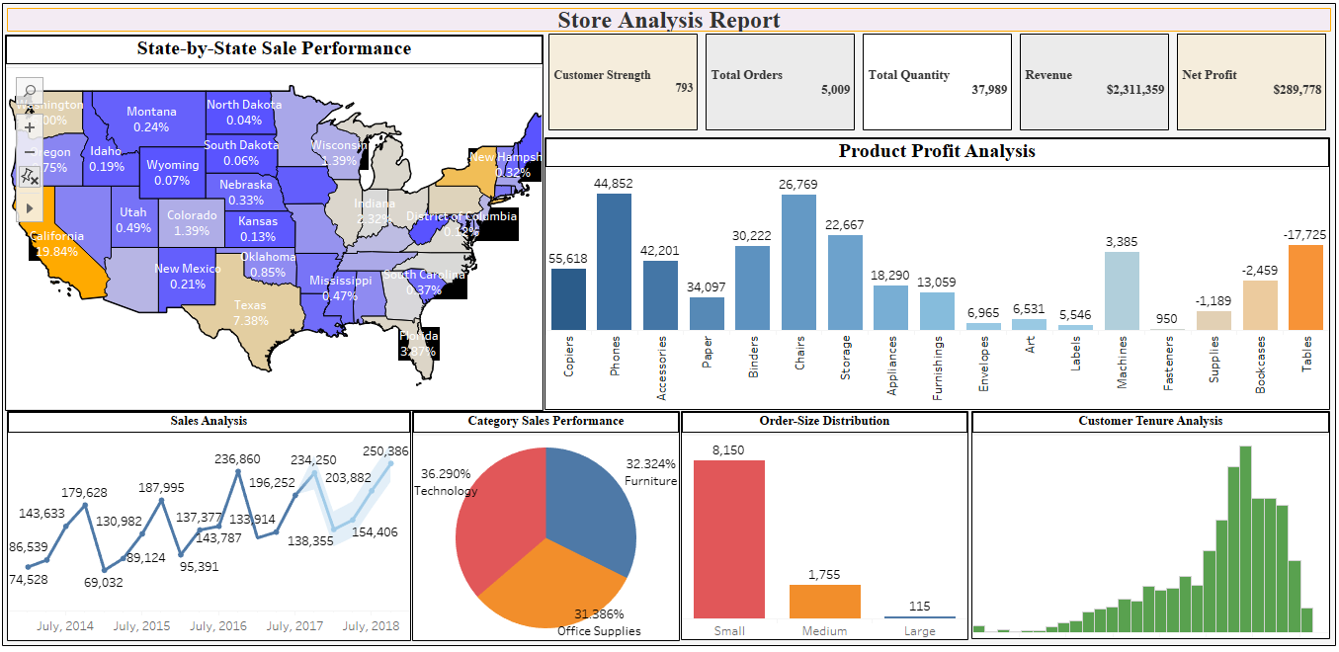

**8. Machine Learning Models**

In addition to data visualization, machine learning models are employed to perform predictive analytics and generate actionable insights. The key aspects of machine learning in the project include:

1. ML Algorithms: Machine learning algorithms, such as RFM (Recency, Frequency, and Monetary) analysis, are applied to identify loyal customers and predict future outcomes.

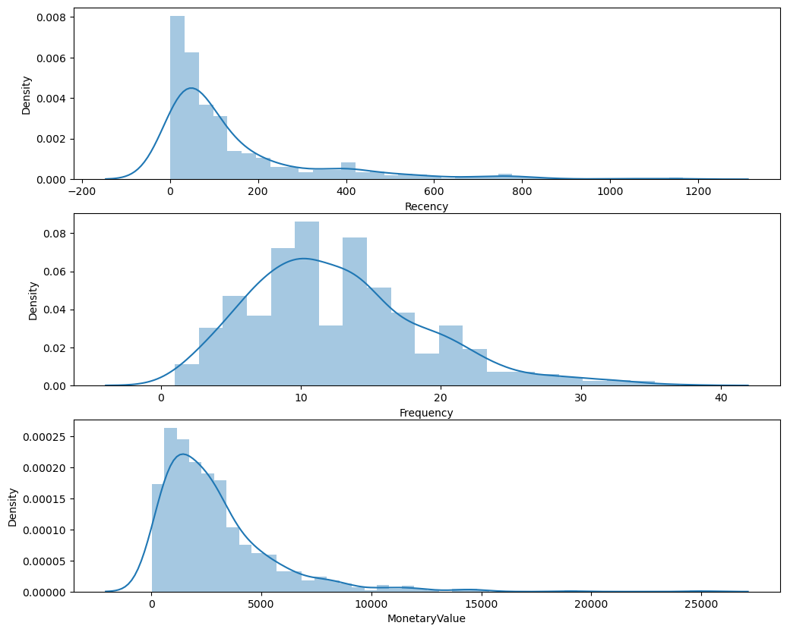

1. Python Scripts: Python scripts in the folder implement the ML algorithms and group customers based on their behaviour.
2. Pareto Principle (80/20 Rule): Observations from the Pareto Principal guide business optimization strategies and focus efforts on high value customers.
3. Customer Segmentation: ML algorithms enable customer segmentation based on purchasing behaviour, demographics, and geographic location.

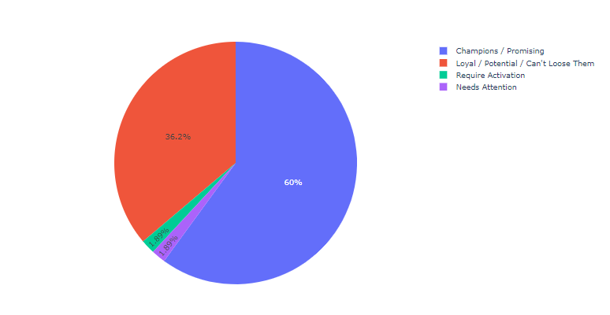

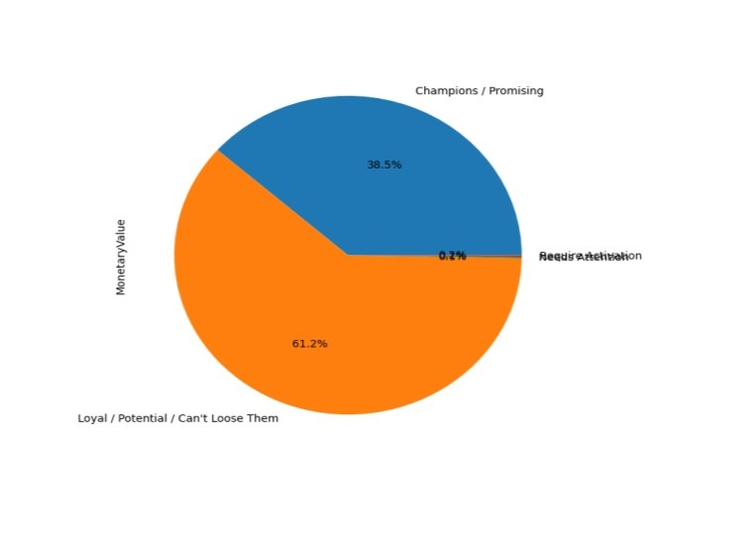

**9. Insights and Recommendations**

The project yields valuable insights into various aspects of the business, including customer behaviour, product performance, and sales trends. Based on these insights, several recommendations are made to optimize business operations and drive growth. Key insights and recommendations include:

1. Customer Strength: Analysis reveals a robust customer base, indicating a strong market presence.
2. Total Orders: A significant volume of orders highlights substantial demand for products or services.
3. Regional Sales Analysis: Sales are particularly strong in certain regions, while others exhibit lower sales.
4. Sales Forecasting Analysis: Time series forecasting predicts an upward trend in sales with discernible seasonality.
5. Product Profitability Analysis: High profit items are identified, along with products with notable losses.
6. Business Optimization Suggestions: Recommendations include developing a loyalty program, optimizing the supply chain, and focusing on customer relationship management.

The project establishes a comprehensive data transformation and analysis pipeline that empowers the company to leverage its data assets effectively. By extracting, transforming, and analysing data from the SuperStore database, the project provides valuable insights into various aspects of the business. Through data visualization and machine learning, stakeholders gain actionable insights to drive strategic decisions and optimize business operations. By following the systematic approach outlined in this documentation, the company can harness the power of data to stay competitive, adapt to market dynamics, and achieve sustainable growth in the ever-evolving business landscape.